Call for teachers – methodological training to help children think critically

Anthropolis and its partners are calling teachers to take part in a 5 day training in Budapest between 5 – 9. May 2018.

The training aims to develop teachers’ capacity to respond to the challenge of how to address difficult and controversial issues in the classroom (e.g. migration, gender, etc).
In order to participate you must be able to meet the following requirements:

- 1. 3 years experience of education (in school, teacher training or related educational provision)
- 2. Proficient level of English to be able to participate fully in the training
- 3. Understanding of EU debate on critical thinking in education
- 4. Willing to provide feedback and reflection on the training experience by completing a post-training reflection activity and delivering activities in a classroom/education context

The training is organised in the frame of a European project, a collaboration between educators in Hungary, Poland, Sweden and the United Kingdom.
What is the project aiming to do?
To support teachers and educators with training and resources to help children think critically about complex and controversial information, and extreme views.
How?
The project will involve five phases, including:
- 5 day training in Philosophy for Children (P4C)
- Sharing experiences between partner countries
- Further training on P4C delivered in each partner country
- Teachers delivering activities in classrooms using P4C to develop critical thinkers
- Development of an online Teacher Toolkit

To apply to participate in the training please tell us something about your interest by responding to the questions below:

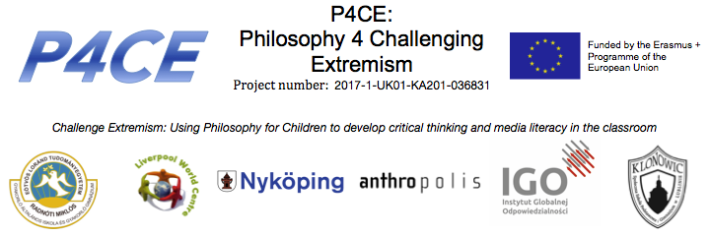
Methodological training for teachers
Application form

- What is your experience and what are you doing currently in relation to promoting dialogue in the classroom? (max 100 words)

- What skills do you hope to gain from participating in the training and how will you apply these? (max 100 words)

- How do you meet the requirements above (1 - 4)? (max 100 words)

